**Sequence Diagram:**

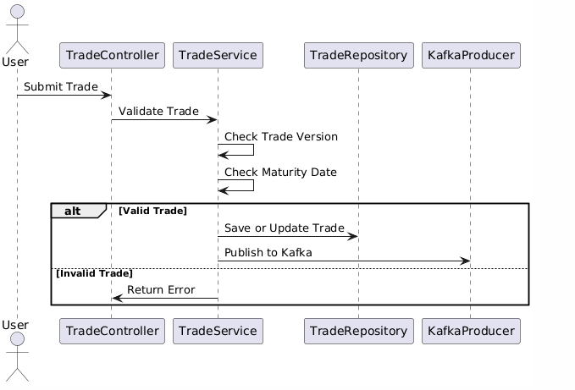

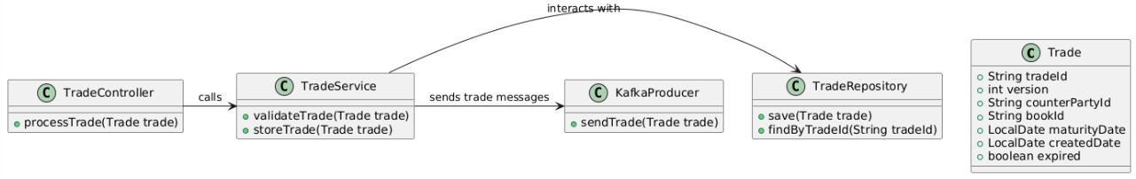

**Results of Test cases run via Soap UI**

Test 1:

|  |  |  |  |  |  |  |
| --- | --- | --- | --- | --- | --- | --- |
| Trade Id | Version | Counter-Party Id | Book-Id | Maturity Date | Created Date | Expired |
| T1 | 1 | CP-1 | B1 | 20/05/2020 | <today date> | N |

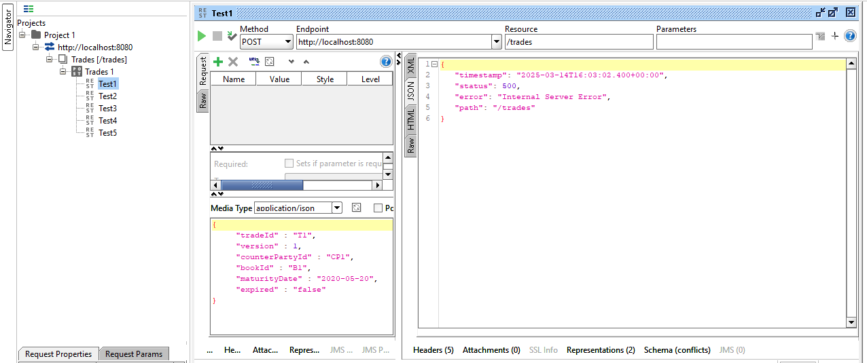

Test 2

|  |  |  |  |  |  |  |
| --- | --- | --- | --- | --- | --- | --- |
| Trade Id | Version | Counter-Party Id | Book-Id | Maturity Date | Created Date | Expired |
| T2 | 2 | CP-2 | B1 | 20/05/2021 | <today date> | N |

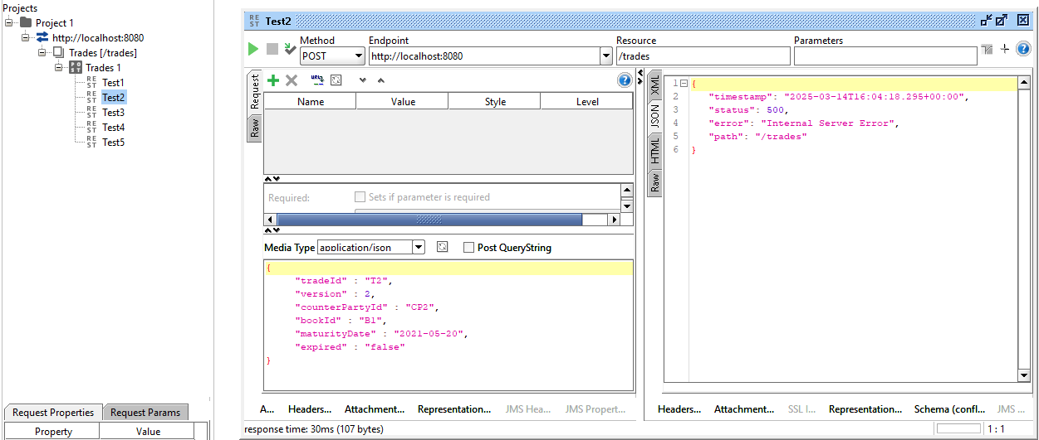

Test 3

|  |  |  |  |  |  |  |
| --- | --- | --- | --- | --- | --- | --- |
| Trade Id | Version | Counter-Party Id | Book-Id | Maturity Date | Created Date | Expired |
| T2 | 1 | CP-1 | B1 | 20/05/2021 | 14/03/2015 | N |

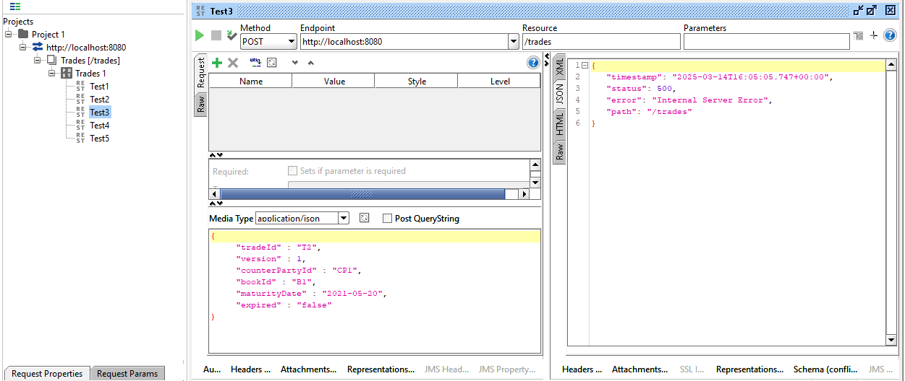

Test4

|  |  |  |  |  |  |  |
| --- | --- | --- | --- | --- | --- | --- |
| Trade Id | Version | Counter-Party Id | Book-Id | Maturity Date | Created Date | Expired |
| T3 | 3 | CP-3 | B2 | 20/05/2014 | <today date> | Y |

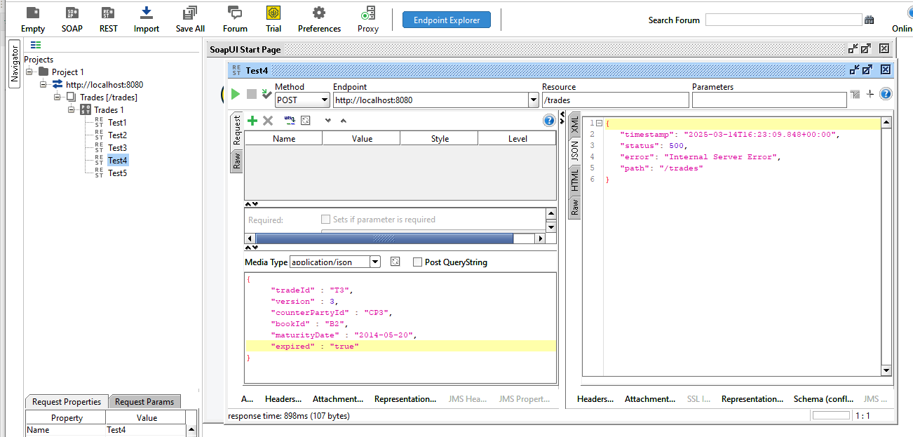

Test 5 – Success

|  |  |  |  |  |  |  |
| --- | --- | --- | --- | --- | --- | --- |
| Trade Id | Version | Counter-Party Id | Book-Id | Maturity Date | Created Date | Expired |
| T2 | 1 | CP-3 | B1 | 20/05/2025 | <today date> | N |

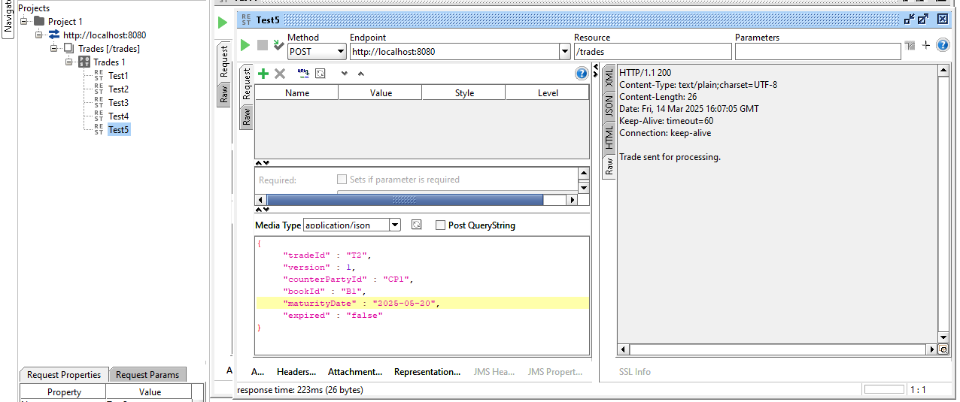

**Data Bases**

